Dessa Shapiro

Period 6

10/20/21

My part of the proposal

-What message do you want the memorial/monument to convey? (2-3 paragraphs)

Education is one of the most important aspects of a community and society since it shapes how people act and the opportunities they are provided. Education leads to knowledge, which leads to power. And since African American people, especially former slaves were not given the option to receive an education they were considered “lower than” and ” beneath'' others. But when these oppressed neglected peoples were finally able to learn, they were able to gain positions of power and spread influence and awareness. In the time of reconstruction, when slavery was newly abolished, education was the most important company for former slaves. It provided them with job opportunities and a stronger hold on society. They were no longer kept ignorant and better able to understand and function in the world. We wanted to create a monument that emphasized the importance of education and recognize the struggle people from the past and what they were able to accomplish and overcome with the little they were given. We thought that this idea was especially important in terms of government positions. Since that was the highest power over the country at the time. And it's important to think about and remember the people who were able to gain enough recognition to be placed into these positions. For this reason, we picked Hiram Rhodes revels as the main subject for our monument. And the overall theme is the Freedmen's schools, built throughout the country. The combination of things provided our monument with specific recognition as well as a more widespread idea that is still in effect today. A connection between the past and the present, today we have public schools across the county, a resource that we often take for granted. Everyone, in theory, is offered the right to an education, and that is something to honor and commensurate, and to do that we need to understand its history and the importance of the freedmen's schools and the people who contributed to creating and passing the freedmen's bureau. So, our overall message is one of equality in education and the importance of the distribution of power. Also to look back on our history and appreciate what we have.

The Slides I made:

.

.

.

.

.

.

.

.

.

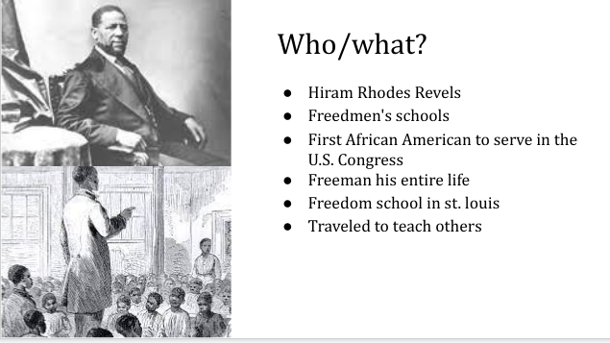

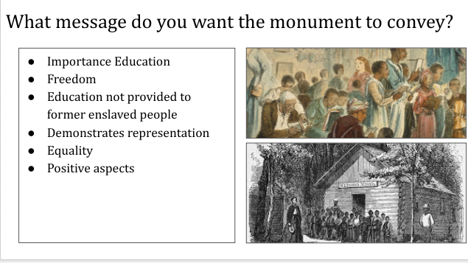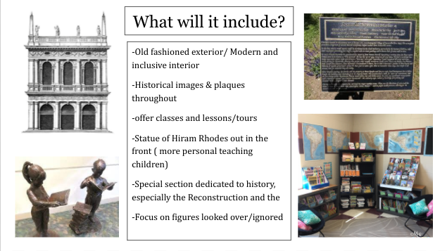

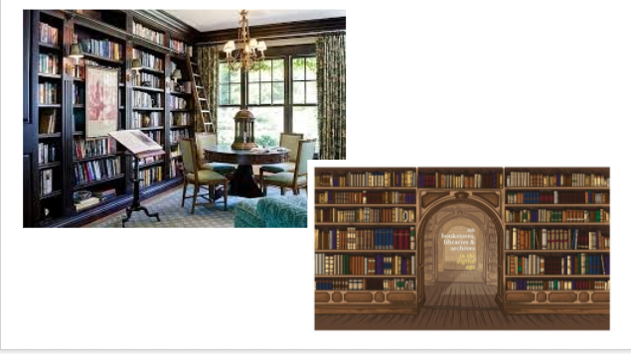

Notes

Dessa Notes:

| Source: <https://history.house.gov/People/Listing/R/REVELS,-Hiram-Rhodes-(R000166)/>  - Dessa  Answers to the questions based on research:  -importance of education  -representation  <https://virginiahistory.org/learn/freedmens-schools> | the first African American to serve in the U.S. Congress  Was a preacher for many years  Filled senate seat in 1870  Born in north Carolina  Was a freeman his entire life ( parent to)  attended a school taught by a free black woman- educating black children was illegal  traveled throughout the country, carrying out religious work and educating fellow African Americans in Indiana, Illinois, Kansas, Kentucky, and Tennessee.  imprisoned for preaching to the black community in 1854  Tried to preach for freedom / spread his message  He served as the chaplain for a black regiment in campaigns in Vicksburg and Jackson, Mississippi. In 1863,  St. Louis, where he established a freedmen’s school.( education was important )  Before the Civil War, fewer than 1,000 free black Mississippians had access to a basic education.  Blck people excluded from an education. It was even illegal in many places. After the civil war schools were built.   * What message do you want the memorial/monument to convey? (2-3 paragraphs)   “many Black people became literate. During the Civil War, northern missionaries and Black teachers established schools in Union-occupied territories”  one of the earliest Black schools was established in the eastern end of the city at Chimborazo in June 1865, on the site where the large Confederate hospital had operated just a few weeks before |
| --- | --- |

All of the sources:

Freedmen’s Schools | Virginia Museum of History & Culture. (2021). Retrieved October 20, 2021, from Virginia Museum of History & Culture website: <https://virginiahistory.org/learn/freedmens-schools>

African Americans and Education During Reconstruction: The Tolson’s Chapel Schools (U.S. National Park Service). (2021). Retrieved October 20, 2021, from Nps.gov website: <https://www.nps.gov/articles/african-americans-and-education-during-reconstruction-the-tolson-s-chapel-schools.htm>

Hiram Rhodes Revels | Biography & Facts | Britannica. (2021). In *Encyclopædia Britannica*. Retrieved from <https://www.britannica.com/biography/Hiram-Rhodes-Revels>

Hiram Rhodes Revels | Biography & Facts | Britannica. (2021). In *Encyclopædia Britannica*. Retrieved from <https://www.britannica.com/biography/Hiram-Rhodes-Revels>

REVELS, Hiram Rhodes | US House of Representatives: History, Art & Archives. (2021). Retrieved October 20, 2021, from @USHouseHistory website: <https://history.house.gov/People/Listing/R/REVELS,-Hiram-Rhodes-(R000166)/>